# Data Structures and Algorithm (DSA)

# Minor Project-1 (2023)

Description

The problem is to create an employee database using classes and objects in Java. The Employee class should have fields for name, employee ID, salary, hire date, job position, contact number, and address. The Date and Address fields should be implemented as separate classes. Additionally, appropriate constructors, getters, and setters should be implemented for these classes.

The program should be able to perform the following operations:

1. Create an array of 500 Employee objects to represent the employee database.

2. Sort the array of Employee objects in descending order by salary.

3. Display the details of all employees whose job position is "manager".

4. Display the details of all employees whose hire date is between April 1st, 2022 and March 31st, 2023.

5. Find the number of foreign employees by checking the country code in their contact number.

6. Display the details of all employees whose salary is between 150000 INR and 300000 INR.

All classes and the main method should be placed in a package named "Ayushmaan_2241013230". A description file (Word document) should be created to explain the implementation process and show the output of the program. The package should be compressed and submitted.

Output:

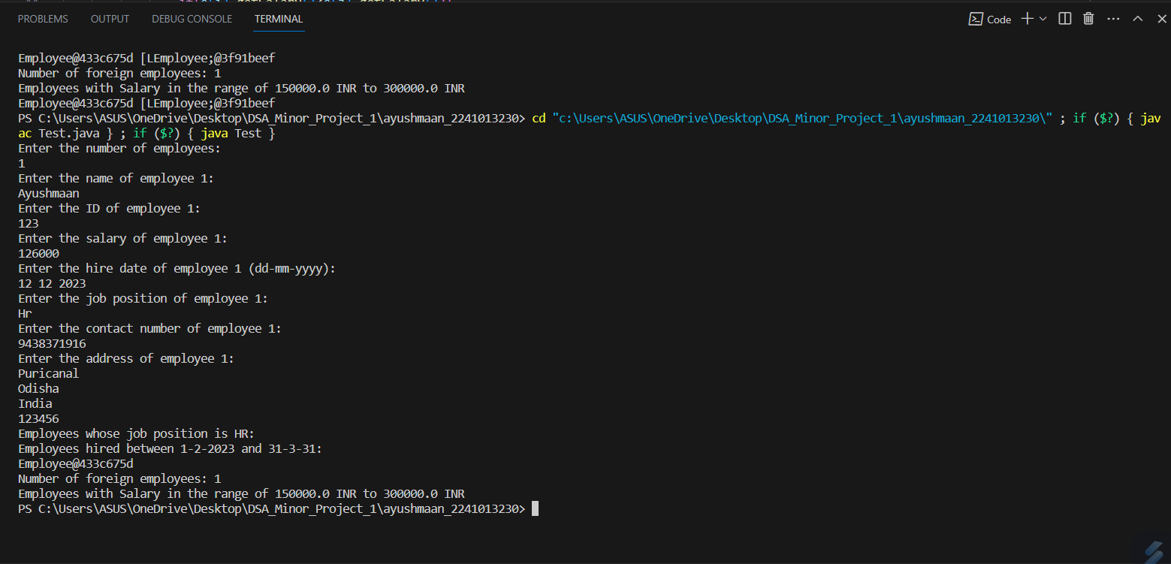

Submitted to: Mr. Gaurav Yadav sir

Name: Ayushmaan Mohanty

Branch: Computer Science Engineering

Section: 2241028 [1st year]

Redg. no: 2241013230

Thank you…